***Experiment No: 2***

*Aryaman Gautam*

*J001*

Aim: Interfacing with Arduino uno

1. Increase the brightness of the external LED which has a delay of 10ms and fade of 10ms

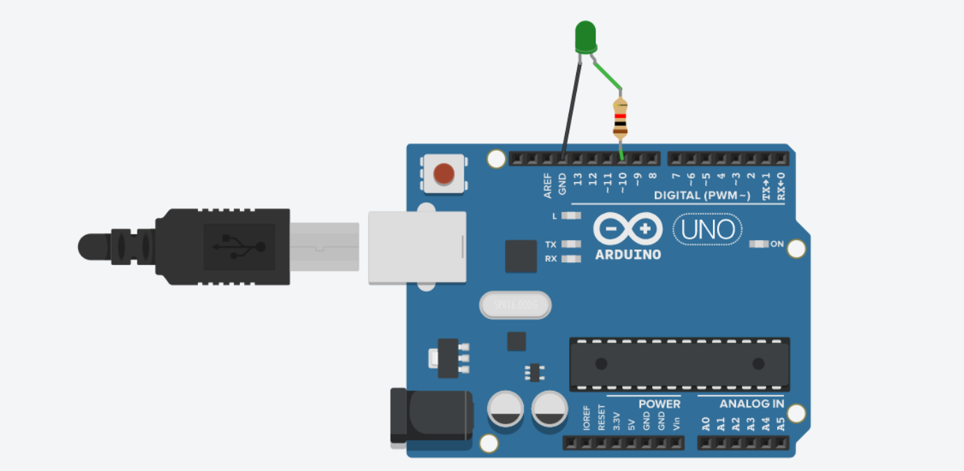

void setup()

{

pinMode(10, OUTPUT);

}

void loop()

{

for(int i=0;i<255;i++){

analogWrite(10,i);

delay(10);

}

for(int i=255; i>0; i--){

analogWrite(10,i);

delay(10);

}

}

1. Increase the brightness of 2 External LED alternatively.

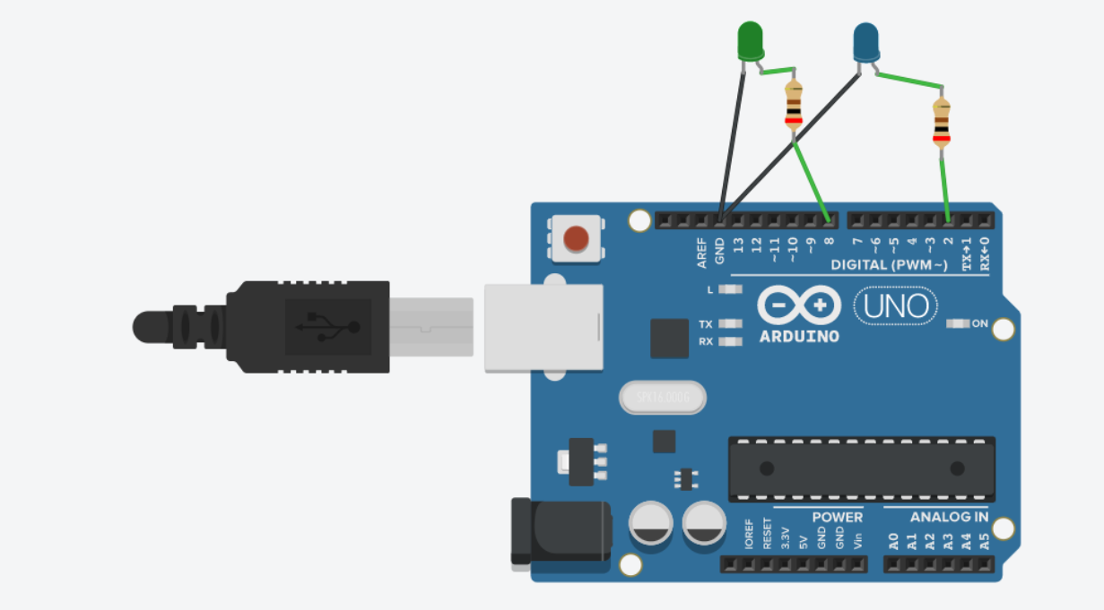 void setup()

{

pinMode(2, OUTPUT);

pinMode(8, OUTPUT);

}

void loop()

{

for (int i=0; i<255; i++){

analogWrite(2,i);

analogWrite(8,255-i);

delay(10);

}

for (int i=255; i>0; i--){

analogWrite(2,i);

analogWrite(8,255-i);

delay(10);

}

}

1. Reading using potentiometer

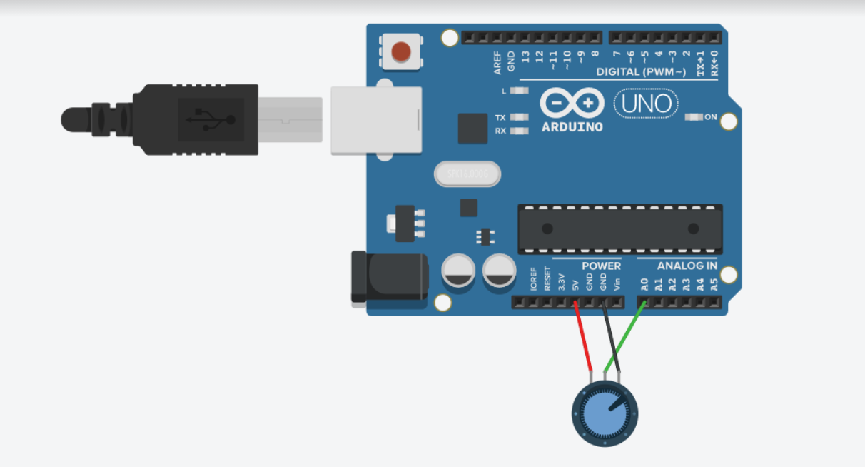

int sensorValue = 0;

void setup()

{

pinMode(A0, INPUT);

Serial.begin(9600);

}

void loop()

{

sensorValue = analogRead(A0);

Serial.println(sensorValue);

delay(10);

}

4. Using potentiometer to control LED brightness

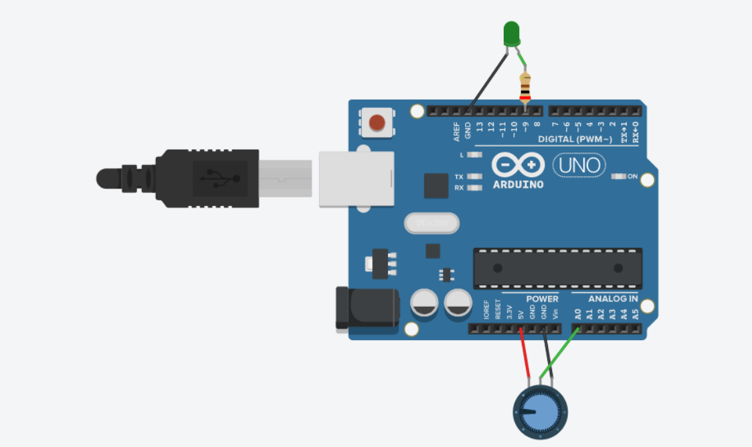

int sensorValue = 0;

int outputValue = 0;

void setup()

{

pinMode(A0, INPUT);

pinMode(9, OUTPUT);

Serial.begin(9600);

}

void loop()

{

sensorValue = analogRead(A0);

outputValue = map(sensorValue, 0, 1023, 0, 255);

analogWrite(9, outputValue);

Serial.print("sensor = ");

Serial.print(sensorValue);

Serial.print("\t output = ");

Serial.println(outputValue);

delay(2);

}

1. Displaying potentiometer resistance on serial monitor

&

1. Displaying potentiometer (variable resistance) on serial plotter

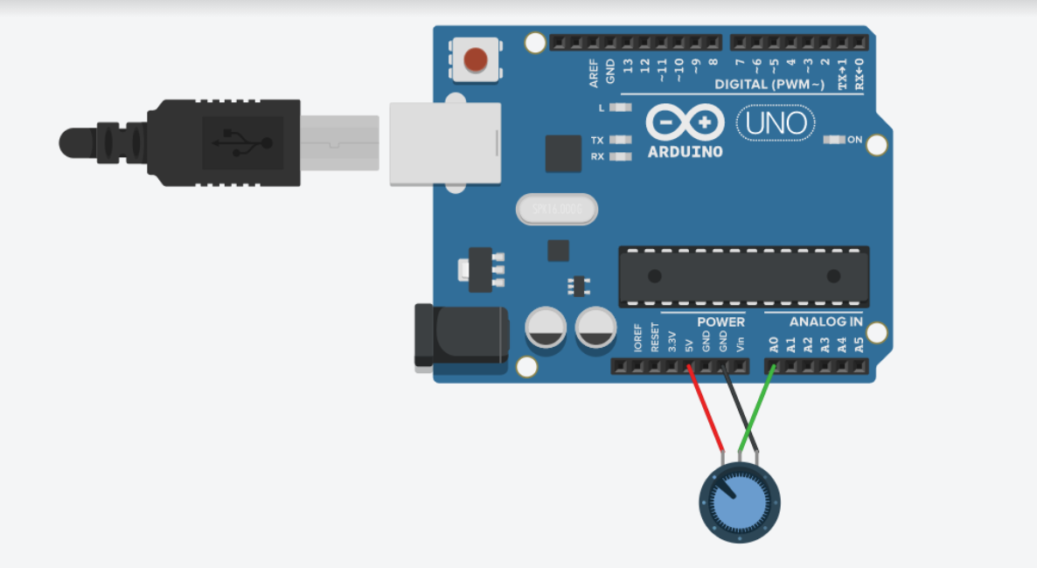

int sensorValue = 0;

void setup()

{

pinMode(A0, INPUT);

Serial.begin(9600);

}

void loop()

{

sensorValue = analogRead(A0);

Serial.println(sensorValue);

delay(10);

}

1. Controlling multiple LEDs using button or switch

&

1. Controlling single LED using switch or button

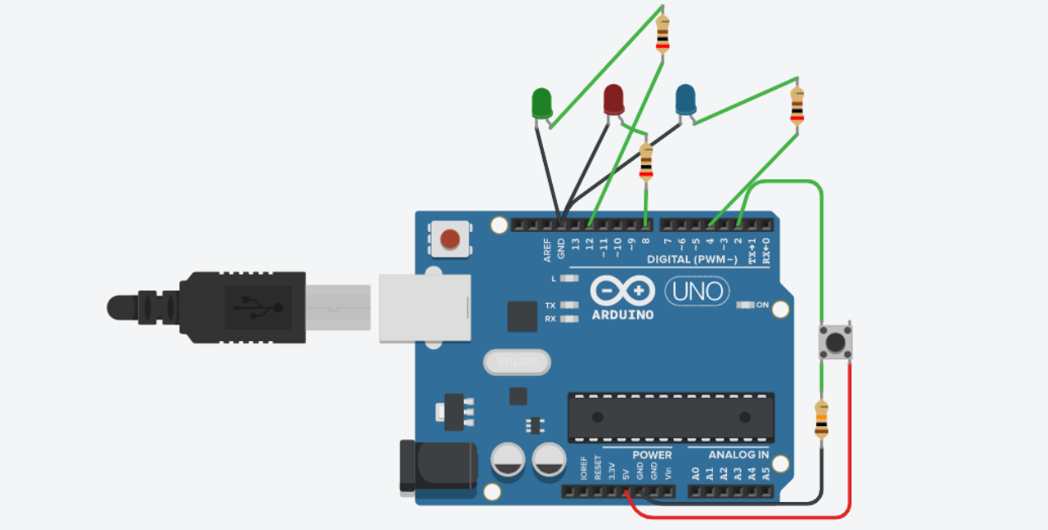

int buttonState = 0;

void setup()

{

pinMode(2, INPUT);

pinMode(12, OUTPUT);

pinMode(8, OUTPUT);

pinMode(4, OUTPUT);

Serial.begin(9600);

}

void loop()

{

buttonState = digitalRead(2);

Serial.println(buttonState);

if (buttonState == 1){

digitalWrite(4,HIGH);

digitalWrite(8, HIGH);

digitalWrite(12, HIGH);

delay(10);

}

else {

digitalWrite(4,LOW);

digitalWrite(8, LOW);

digitalWrite(12, LOW);

delay(10);

}

}

1. Displaying switch state or button state on serial plotter

&

1. Reading inputs from a switch or button on serial monitor

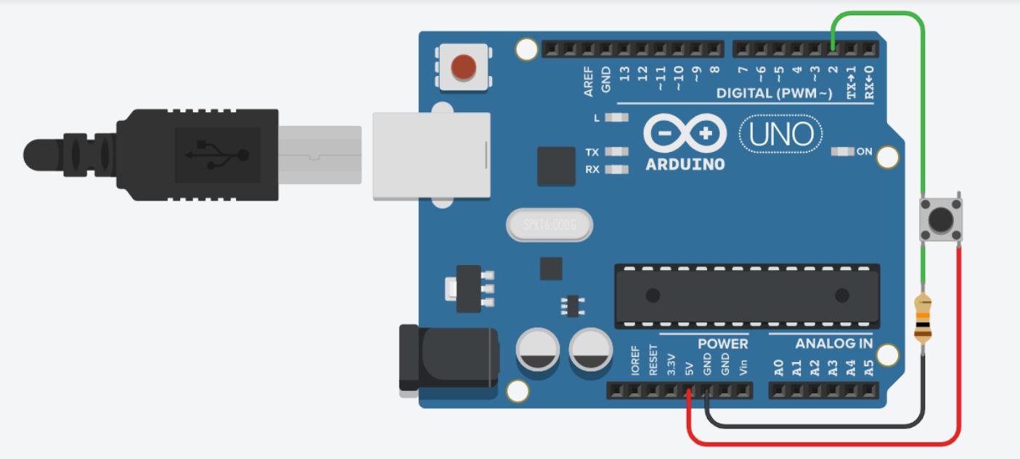

int buttonState = 0;

void setup()

{

pinMode(2, INPUT);

Serial.begin(9600);

}

void loop()

{

buttonState = digitalRead(2);

Serial.println(buttonState);

delay(10);

}